Exercise induced pulmonary hemorrhage (EIPH)
(Bleeders)
Definition: exercise induced pulmonary hemorrhage (EIPH) has been used to describe the bleeding of pulmonary origin associated with intense physical activities. Due its important economical losses, the disorder is considered one of the biggest problems affecting athletic horses.
Importance
EIPH is of great concern to the racing industry because of the financial implications resulting from decreased performance, lost training days, necessity for prerace medication, and banning of horses from racing.

Etiology
EIPH is a multi-factorial condition involving airway, vascular, cardiac and locomotory components and that the contribution of different factors varies between individual horses and possibly even within the same horse over time.
- strenuous exercise and/or pathophysiological changes in the equine lung
- pulmonary hypertension due to cardiac diseases
- inflammatory airway disease exacerbate the condition

Pathophysiology
- EIPH is characterized by pulmonary hypertension, edema in the gas exchange region of the lung, rupture of the pulmonary capillaries, intra-alveolar hemorrhage, and the presence of blood in the airways.
- The most widely accepted theory at present is that of pulmonary capillary stress failure due to high transmural pressures (pressures or stresses acting on the pulmonary capillaries). Pulmonary capillary transmural pressure is determined by pulmonary capillary pressure and airway pressure. The horse has high pulmonary vascular pressures during intense exercise. When the high pulmonary vascular pressures (exceeding 100 mmHg) distending the blood vessels are opposed by high positive airway pressures, such as occur during expiration, the transmural pressure (and by implication, wall stress) will be low. However, when the distending internal vascular pressure is associated with a large negative airway pressure (as occurs during inspiration), the transmural pressure and wall stress will be high.

Diagnosis
1-Case History
2-Clinical signs
3-Bronchoscopic examination to determine the severity according to a scoring system (grades from 0 to 4)
- Grade 0: no blood detected in the pharynx, larynx, trachea, or mainstem bronchi.
- Grade 1: presence of one or more flecks of blood or two or fewer short (less than one-quarter the length of the trachea) and narrow (<10% of the tracheal surface area) streams of blood in the trachea or mainstem bronchi visible from the tracheal bifurcation.
- Grade 2: one long stream of blood (more than one-half the length of the trachea) or more than two short streams of blood occupying less than one-third of the tracheal circumference.
- Grade 3: multiple, distinct streams of blood, covering more than one-third of the tracheal circumference, with no blood pooling at the thoracic inlet.
- Grade 4: multiple, coalescing streams of blood covering >90% of the tracheal surface with blood pooling at the thoracic inlet.

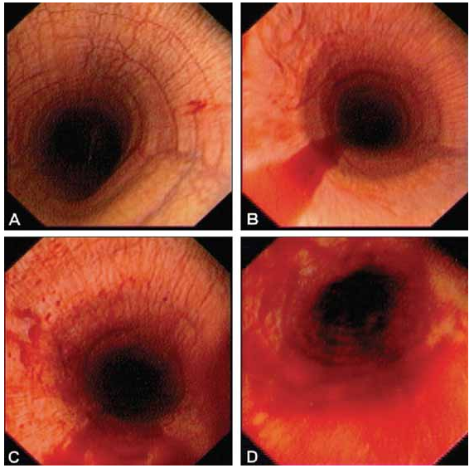
Illustrative examples of grade 1 (A), 2 (B), 3 (C), and 4 (D) pulmonary hemorrhage in Thoroughbred race horses.Grade 0, in which blood is not detected during tracheobronchoscopic examination, is not illustrated.

Treatment
Hygienic treatment
- Complete rest
- Water restriction
Medicated treatment
- Anti-inflammatories (e.g. corticosteroids),
- Bronchodilators,
- Anti-hypertensive agents (including nitric oxide donors and phosphodiesterase inhibitors),
- antifibrinolytics (e.g. aminocaproic acid and tranexamic acid),
- Aspirin,
- Vitamin K
- Diuretics (e.g. furosemide, known as Lasix or Salix),
- Concentrated equine serum (CES)
- Omega-3 fatty acids.
